Install postgres and postico. Link here ---> <https://postgresapp.com/>



Postgres (left ) Postico (right)

Make sure Postgres is running by hitting the start button. Next, go to postico, and make a “New favorite” connection. The credentials are the following…

nickname - “proj”,

host - “locolhost”,

user - “postgres”,

password - ‘’password”

Database – “spotifyProject”



Next create a database if it is not already created. Now create a table within the database and call it “top2018” and create the following 8 columns as seen in the picture below and include the type as seen below.A screenshot of a computer
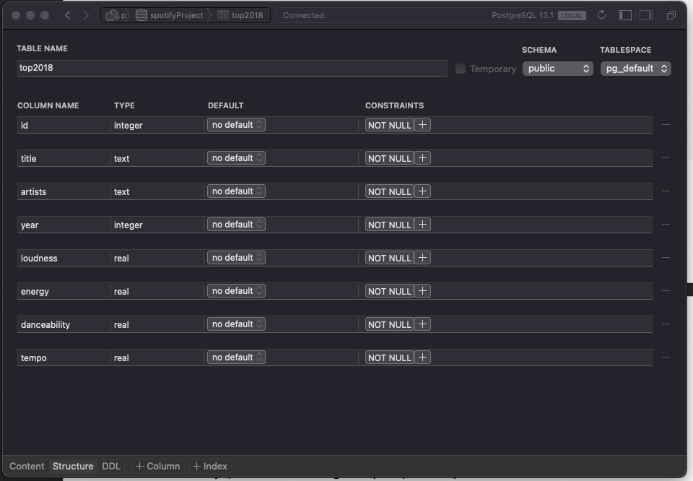



Once completed there is a save changes button, click it. Now, go back to the previous page and right click on the table to import csv. Select the top2018.csv from the Data folder. Make sure to match the coulmns by name and to have the same settings like the picture below. Afterwards click ‘import’ and you are all set. 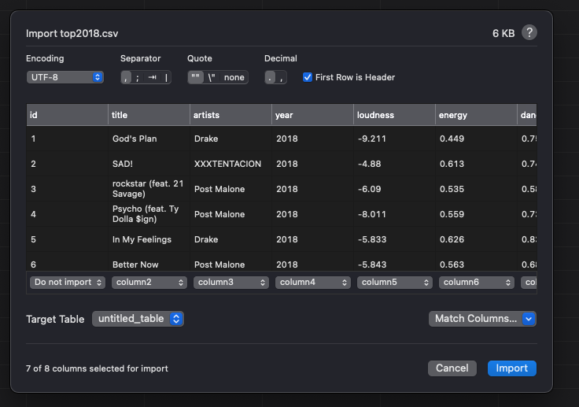



Install node.js (follow instructions given by the professor)